There are certain modules that need to be installed before you can run the email function code.

Hickory

This package lets you schedule when to run the email function code

1. To install go to terminal in your raspberry pi and type “pip3 install hickory or pip install hickory”
2. Once it is successfully installed you should be able to use the hickory function to set a schedule for the code.

Remote Access

This helps you avoid using a monitor when working on the project.

1. Go to <https://www.realvnc.com/en/connect/download/vnc/>
2. Download VNC server and make sure you download the version that works best for your operating system.
3. Once you are able to download VNC server to your operating system open up VNC server.
4. Click CRTL+N and it should take you to the properties that looks like this. 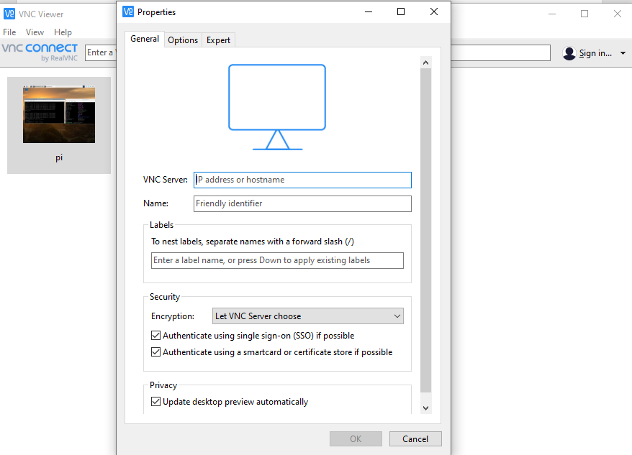
5. Now go to your raspberry pi and open up terminal and make sure the raspberry pi is connected to Wi-Fi. Once you open up terminal type in “hostname -I”. Copy the IP address you see on terminal
6. Once you see an IP address in terminal go back to VNC server and type the IP address you see in the VNC Server box. For name box you can just type the name you have for the raspberry or even type just Pi it does not matter. Once you click ok it should try to connect to the raspberry pi.
7. It will then ask you to type in the username and password for the pi. If you are using a default raspberry pi the username should “pi” and the password should be “raspberry”. If that does not work try typing “pi” as the username and then “Classof2021” as the password.
8. If you are able to log in successfully you should be able to have remote access to the raspberry pi.